**Predicting the Presence of Heart Disease in Patients**



Heart disease is one of the biggest cause of Death among the population of the world.

Prediction of cardiovascular disease is considered as one of the most important subjects in the section of clinical data analysis.

In this blog-post, I will be applying Machine Learning approaches for ***classifying whether a person is suffering from Heart Disease or not*** by using Cleveland Heart Disease Dataset from the UCI Repository.

**Dataset link**: <https://archive.ics.uci.edu/ml/datasets/heart+disease>

***Importing necessary library***

**import** **pandas** **as** **pd**

**import** **numpy** **as** **np**

***#Data Visualization***

**import** **matplotlib.pyplot** **as** **plt**

%matplotlib inline

**import** **seaborn** **as** **sns**

**from** **sklearn.model_selection** **import** train_test_split

***#Importing warnings***

**import** **warnings**

warnings.filterwarnings('ignore')

# *Getting the Data*

df=pd.read_csv('heart_diseaseucimachine.csv')

df.head()

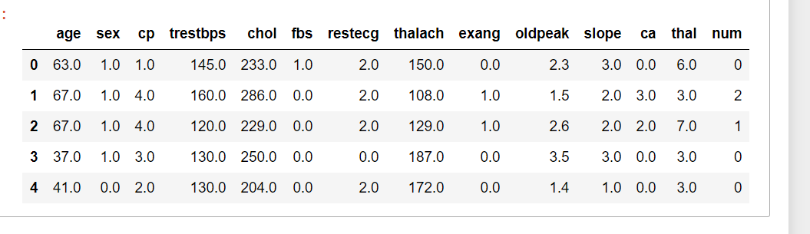

In this dataset 303 rows & 14 columns are present,which is describes below:

1.***Age***:displays the age of individual in years

2.***Sex***: displays the gender of individual

1 = male

0 = female

3.***cp***( *chest pain type*) :displays the type of chest pain experienced by individual;

1: typical angina

2: atypical angina

3: non-anginal pain

4: asymptomatic

4.***trestbps:***displays ***resting blood pressure*** of an individual (in mm Hg on admission to the hospital)

5.***chol***:displays ***serum cholestoral*** in mg/dl

6***.fbs***:compares the ***fasting blood sugar***

If fbs > 120 mg/dl,then

1 = true , 0 = false

7.***restecg***:displays ***resting electrocardiographic*** results

0: normal

1: having ST-T wave abnormality

2: showing probable or definite left ventricular hypertrophy 8.***thalach***:displays ***maximum heart rate*** achieved 9.***exang***:(exercise induced angina)

1 = yes , 0 = no

10.***oldpeak***-ST depression induced by exercise relative to rest

11.***slope***- the slope of the peak exercise ST segment

1: upsloping

2: flat

3: downsloping

12.***ca***-number of ***major vessels*** (0-3) colored by flourosopy

13.***thal:***displays the ***thalassemia***

3 = normal ,

6 = fixed defect ,

7 = reversable defect

14.***num***:displays whether the individual is suffering from heart disease or not(***target column)***

0=absence

1,2,3,4=present

# *Data Exploration/Analysis*

df.info()

<class 'pandas.core.frame.DataFrame'>

RangeIndex: 303 entries, 0 to 302

Data columns (total 14 columns):

# Column Non-Null Count Dtype

--- ------ -------------- -----

0 age 303 non-null float64

1 sex 303 non-null float64

2 cp 303 non-null float64

3 trestbps 303 non-null float64

4 chol 303 non-null float64

5 fbs 303 non-null float64

6 restecg 303 non-null float64

7 thalach 303 non-null float64

8 exang 303 non-null float64

9 oldpeak 303 non-null float64

10 slope 303 non-null float64

11 ca 303 non-null object

12 thal 303 non-null object

13 num 303 non-null int64

dtypes: float64(11), int64(1), object(2)

memory usage: 33.3+ KB

***Observation:***

1.All columns are of float64 type except ca & thal

2.ca & thal are of object type

* First I will find the **missing data** present in dataset.

df.isnull().sum().any()

False

It shows that no null values are present in dataset,but we notice that some ‘?’ are present in our datasert

*# in the given dataset some ‘?’ are present,replacing '?' with nan value in ca & thal column*

df.replace({'ca':{'?':np.nan}},regex=**False**,inplace=**True**)

df.replace({'thal':{'?':np.nan}},regex=**False**,inplace=**True**)

we **need to convert 2 categorical features into**

**numeric** ones so that the machine learning algorithms

can process them.

*#changing object type to float type*

col=['ca','thal']

**for** c **in** col:

df[c]=df[c].astype(float)

# Checking null values

df.isnull().sum()

age 0

sex 0

cp 0

trestbps 0

chol 0

fbs 0

restecg 0

thalach 0

exang 0

oldpeak 0

slope 0

ca 4

thal 2

num 0

dtype: int64

we see that there are only 6 cells with null value,with 4 belonging to attribute ca & 2 to thal, that wee need to deal with.

As null values are very less,we can either drop them or impute them.I have imputed most frequent/mode in place of null vlaue

# Imputing null values

**from** **sklearn.impute** **import** SimpleImputer

imp=SimpleImputer(strategy='most_frequent')

df['ca']=imp.fit_transform(df['ca'].values.reshape(-1,1))

df['thal']=imp.fit_transform(df['thal'].values.reshape(-1,1))

df.isnull().any()

# false

# We see that null value have been removed.

# 

# *Summary Statistics*

# Now we will check information about all the numerical column

df.describe()

# 

| **age** | **sex** | **cp** | **trestbps** | **chol** | **fbs** | **restecg** | **thalach** | **exang** | **oldpeak** | **slope** | **ca** | **thal** | **num** |
| --- | --- | --- | --- | --- | --- | --- | --- | --- | --- | --- | --- | --- | --- |
| **count** | 303.000000 | 303.000000 | 303.000000 | 303.000000 | 303.000000 | 303.000000 | 303.000000 | 303.000000 | 303.000000 | 303.000000 | 303.000000 | 303.000000 | 303.000000 | 303.000000 |
| **mean** | 54.438944 | 0.679868 | 3.158416 | 131.689769 | 246.693069 | 0.148515 | 0.990099 | 149.607261 | 0.326733 | 1.039604 | 1.600660 | 0.663366 | 4.722772 | 0.937294 |
| **std** | 9.038662 | 0.467299 | 0.960126 | 17.599748 | 51.776918 | 0.356198 | 0.994971 | 22.875003 | 0.469794 | 1.161075 | 0.616226 | 0.934375 | 1.938383 | 1.228536 |
| **min** | 29.000000 | 0.000000 | 1.000000 | 94.000000 | 126.000000 | 0.000000 | 0.000000 | 71.000000 | 0.000000 | 0.000000 | 1.000000 | 0.000000 | 3.000000 | 0.000000 |
| **25%** | 48.000000 | 0.000000 | 3.000000 | 120.000000 | 211.000000 | 0.000000 | 0.000000 | 133.500000 | 0.000000 | 0.000000 | 1.000000 | 0.000000 | 3.000000 | 0.000000 |
| **50%** | 56.000000 | 1.000000 | 3.000000 | 130.000000 | 241.000000 | 0.000000 | 1.000000 | 153.000000 | 0.000000 | 0.800000 | 2.000000 | 0.000000 | 3.000000 | 0.000000 |
| **75%** | 61.000000 | 1.000000 | 4.000000 | 140.000000 | 275.000000 | 0.000000 | 2.000000 | 166.000000 | 1.000000 | 1.600000 | 2.000000 | 1.000000 | 7.000000 | 2.000000 |
| **max** | 77.000000 | 1.000000 | 4.000000 | 200.000000 | 564.000000 | 1.000000 | 2.000000 | 202.000000 | 1.000000 | 6.200000 | 3.000000 | 3.000000 | 7.000000 | 4.000000 |

# *From above summary statistics ,we observe that:*

# 1.Minimum age is 29 & maximum age is 77.

# 2.std. deviation is maximum in chol.

# 3.In chol columns the difference b\w 75% & maxm is more,so outliers may be present.

*#checking unique values of target column*

df['num'].value_counts()

0 164

1 55

2 36

3 35

4 13

Name: num, dtype: int64

# Here df['num'] shows whether a person is suffering from heart disease or not;

# 0=absence(not suffering) ,

# (1,2,3,4)=present(suffering)

#*performing mapping in target column*

df['num']=df.num.map({0:0,1:1,2:1,3:1,4:1})

df['num'].value_counts()

0 164

1 139

Name: num, dtype: int64

**we nocice that out of total 139 people are suffering from heart disease**

# *Now we will try to find 0ut,******What features could contribute to cardiovascular disease ?*****

# First we check correlation between the columns.

# check corelation

plt.figure(figsize=(12,8))

sns.heatmap(df.corr(),annot=**True**)

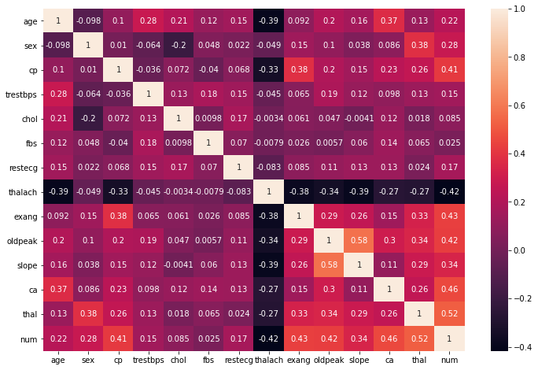

# *Observation:*

# 1.num is negatively corelated with thalach & posively corelated wiyh thal

# 2. most columns are moderately correlated with num, but 'fbs' is weakly correlated.

*#Checking correlation with the traget variable .ie num*

plt.figure(figsize=(8,6))

df.drop('num',axis=1).corrwith(df['num']).plot(kind='bar',grid=**True**)

plt.xticks(rotation=20)

plt.title('correlation with target variable'

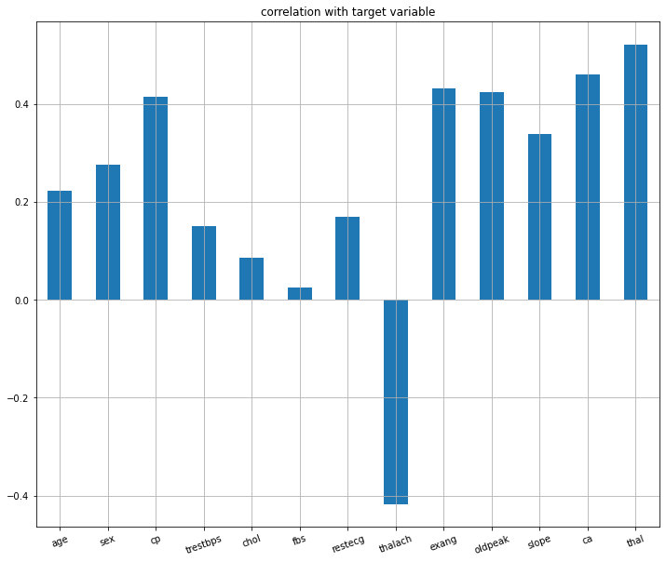

* We see that ***fbs*** is very ***weakly correlated*** with num.So it can be dropped

*#drop fbs*

df.drop('fbs',axis=1,inplace=**True**)

# Now we perform some DATA VISUALIZATION

# 1.sex vs num

sns.barplot(x=df["sex"],y=df['num'])

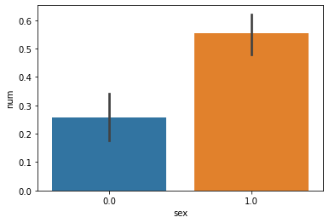

# we notice that males are more likely to have heart problems than female.

**2.cp vs num**

sns.barplot(df["cp"],y=df['num'])

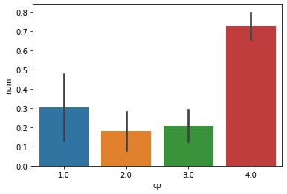

**From graph we notice, that chest pain of type '4.0', i.e. asymptomatic are much more likely to have heart problems**

**3.restecg vs num**

sns.barplot(df["restecg"],y=df['num'])

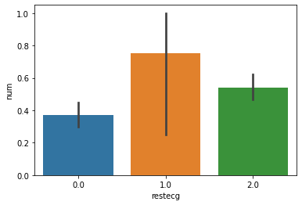

**We notice that people with restecg '1'(having ST-T wave abnormality ) are much more likely to have a heart disease**

**4.exang vs num**

sns.barplot(df["exang"],y=df['num'])

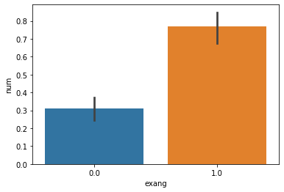

**People with exang=1 i.e. Exercise induced angina are more likely to have heart problems**

**5.slope vs num**

sns.barplot(df["slope"],y=df['num'])

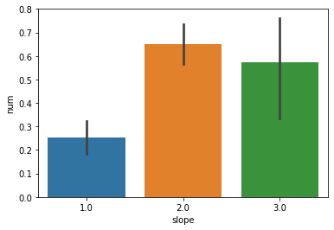

**from graph,it is clear that Slope >= 2 causes more heart problem**

**6.ca vs num**

sns.barplot(df["ca"],y=df['num'])

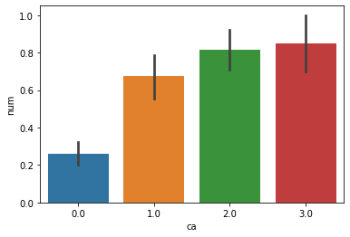

**ca=2.0 & 3.0 has large number of heart patients**

**7.age vs num**

Here we look at the people’s age who are suffering from the disease or not.

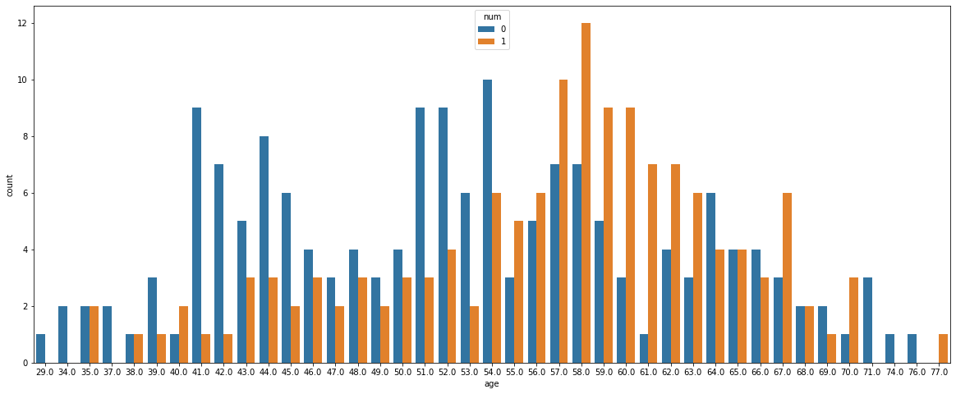

We see that most of the people who are suffering are of the age 58,followed by 57.

Majorly people belonging to the age above 50 are suffering from disease**.**

* **Next ,we look at distribution of age & sex for each target class**

sns.barplot(x='num',y='age',hue='sex',data=df)

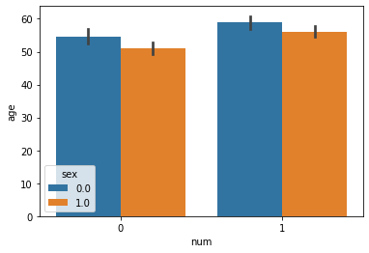

We see that females who are suffering from the disease are older than males.

In this blog,I will be using the following models for classification:

1.Logistic Regression

2.Decison Tree Classifier

3.SVC

4.GaussianNB

5.KNeighborsClassifier

6.RandomForestClassifier

7.AdaboostClassifier

***Checking skewness & outliers***

Now by using boxplot,we check if outliers are present or not.

**Outliers** are nothing ,but the abnormal data present in the dataset,that deviates from other observation in dataset.

df.plot(kind='box',subplots=**True**,layout=(4,4),figsize=(15,10))

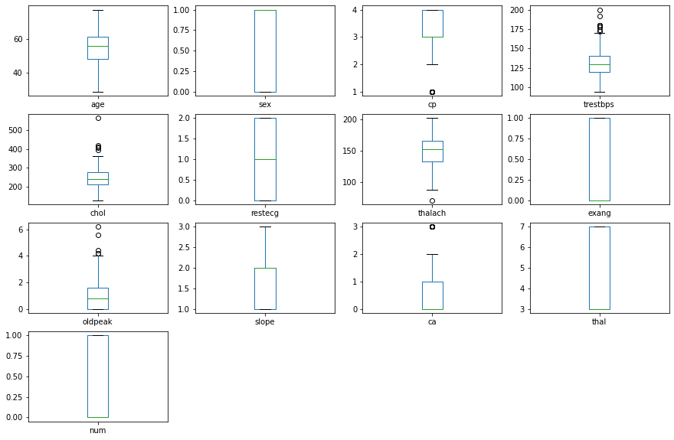

we see that outliers are **present**,which we need to remove.

***Checking skewness***

The skewness is a measure of how asymmetrical our data is distributed

If distribution is between -0.5 & 0.5,the distribution is approximately symmetric

**df.skew()**

age -0.209060

sex -0.774935

cp -0.841754

trestbps 0.706035

chol 1.135503

restecg 0.019900

thalach -0.537449

exang 0.742532

oldpeak 1.269720

slope 0.508316

ca 1.208791

thal 0.256375

num 0.166406

dtype: float64

**We see that skewness is present in the data,which needs to be removed**

***#remove skewness***

**for** col **in** df.columns:

**if** df[col].skew()>0.55:

df[col]=np.log1p(df[col])

**for** col **in** df.columns:

**if** df[col].skew()<-0.55:

df[col]=np.log1p(df[col])

* Again checking skewness

df.skew()

age -0.209060

sex -0.774935

cp -1.266692

trestbps 0.281940

chol 0.081733

restecg 0.019900

thalach -0.537449

exang 0.742532

oldpeak 0.396825

slope 0.508316

ca 0.770355

thal 0.256375

num 0.166406

Skewness has been removed.

# Removing Outliers

**from** **scipy.stats** **import** zscore

z_score=abs(zscore(df))

print(df.shape)

df_new=df.loc[(z_score<3).all(axis=1)]

print(df_new.shape)

(303, 13)

(298, 13)

We see that outliers have been removed.Before, dataset consist of 303 rows & 13 columns .Dataset after removal of outliers contains 298 rows & 13 columns.

*#spliting the data into input and output variable*

x=df_new.iloc[:,:-1]

x.shape

(298, 12)

y=df_new.iloc[:,-1]

y.shape

(298,)

***Scaling the input variable***

We apply standard scaling to make sure that all features are on same scale so that each feature is equally important & make it easier to process by most ML algorithm.

**from** **sklearn.preprocessing** **import** StandardScaler

sc=StandardScaler()

x=sc.fit_transform(x)

# Train_Test_Split

Now let us divide the data into train & test set.

In this project ,I have divided the data into 80:20 ratio

.ie training size is 80% & testing size is 20% of the whole data.

**from** **sklearn.model_selection** **import** train_test_split

x_train,x_test,y_train,y_test=train_test_split(x,y,test_size=.20,random_state=42)

print('x_train_shape:',x_train.shape) print('x_test_shape:',x_test.shape) print('y_train_shape:',y_train.shape) print('y_test_shape:',y_test.shape

x_train_shape: (238, 12)

x_test_shape: (60, 12)

y_train_shape: (238,)

y_test_shape: (60,)

*#importing our models library*

**from** **sklearn.linear_model** **import** LogisticRegression

**from** **sklearn.tree** **import** DecisionTreeClassifier

**from** **sklearn.svm** **import** SVC

**from** **sklearn.naive_bayes** **import** GaussianNB

**from** **sklearn.neighbors** **import** KNeighborsClassifier

*#importing metrics*

**from** **sklearn.metrics** **import** accuracy_score,classification_report,confusion_matrix

# logistic regression

max_accuracy_score=0

**for** r_state **in** range(30,100):

x_train,x_test,y_train,y_test=train_test_split(x,y,random_state=r_state,test_size=.20)

lg=LogisticRegression()

lg.fit(x_train,y_train)

lg_pred=lg.predict(x_test)

accuracy_scr=accuracy_score(y_test,lg_pred)

**if** accuracy_scr>max_accuracy_score:

max_accuracy_score=accuracy_scr

final_r_state=r_state

print('max accuracy score corresponding to ',final_r_state,'is',max_accuracy_score)

**max accuracy score corresponding to 55 is 0.9166666666666666**

x_train,x_test,y_train,y_test=train_test_split(x,y,test_size=.20,random_state=55)

* lg=LogisticRegression()

lg.fit(x_train,y_train)

predlg=lg.predict(x_test)

print('accuracy_score:',accuracy_score(y_test,predlg))

print(confusion_matrix(y_test,predlg))

print(classification_report(y_test,predlg))

**accuracy_score**: 0.9166666666666666

[[29 3]

[ 2 26]]

precision recall f1-score support

0 0.94 0.91 0.92 32

1 0.90 0.93 0.91 28

accuracy 0.92 60

macro avg 0.92 0.92 0.92 60

weighted avg 0.92 0.92 0.92 60

Decision Tree Classifier

**from** **sklearn.model_selection** **import** GridSearchCV

parameters={'criterion':['gini','entropy'],'random_state':range(40,100)}

dtc=DecisionTreeClassifier()

clf=GridSearchCV(dtc,parameters)

clf.fit(x,y)

print(clf.best_params_)

**{'criterion': 'gini', 'random_state': 41}**

**#dtc with best parameters**

dtc=DecisionTreeClassifier(criterion='gini',random_state=41)

dtc.fit(x_train,y_train)

preddtc=dtc.predict(x_test)

print('accuracy_score:',accuracy_score(y_test,preddtc))

print('**\n**')

print(confusion_matrix(y_test,preddtc))

print('**\n**')

print(classification_report(y_test,preddtc))

**accuracy_score**: 0.7833333333333333

[[25 7]

[ 6 22]]

precision recall f1-score support

0 0.81 0.78 0.79 32

1 0.76 0.79 0.77 28

accuracy 0.78 60

macro avg 0.78 0.78 0.78 60

weighted avg 0.78 0.78 0.78 60

# SVC

*#gridsearchcv*

parameters={'kernel':['linear','rbf'],'C':[1,10],'random_state':range(40,100)}

svc=SVC()

clf=GridSearchCV(svc,parameters)

clf.fit(x,y)

print(clf.best_params_)

{'C': 1, 'kernel': 'rbf', 'random_state': 40}

*#svc with best parameter*

svc=SVC(kernel='rbf',C=1,random_state=40)

svc.fit(x_train,y_train)

predsvc=svc.predict(x_test)

print('accuracy_score:',accuracy_score(y_test,predsvc))

print('**\n**')

print(confusion_matrix(y_test,predsvc))

print('**\n**')

print(classification_report(y_test,predsvc))

**accuracy_score**: 0.9166666666666666

[[29 3]

[ 2 26]]

precision recall f1-score support

0 0.94 0.91 0.92 32

1 0.90 0.93 0.91 28

accuracy 0.92 60

macro avg 0.92 0.92 0.92 60

weighted avg 0.92 0.92 0.92 60

# Naive Bayes

gnb=GaussianNB()

gnb.fit(x_train,y_train)

predgnb=gnb.predict(x_test)

print('accuracy_score:',accuracy_score(y_test,predgnb))

print('**\n**')

print(confusion_matrix(y_test,predgnb))

print('**\n**')

print(classification_report(y_test,predgnb))

**accuracy_score**: 0.9

[[29 3]

[ 3 25]]

precision recall f1-score support

0 0.91 0.91 0.91 32

1 0.89 0.89 0.89 28

accuracy 0.90 60

macro avg 0.90 0.90 0.90 60

weighted avg 0.90 0.90 0.90 60

# KNN

knn=KNeighborsClassifier()

knn.fit(x_train,y_train)

predknn=knn.predict(x_test)

print('accuracy_score:',accuracy_score(y_test,predknn))

print('**\n**')

print(confusion_matrix(y_test,predknn))

print('**\n**')

print(classification_report(y_test,predknn))

**accuracy_score**: 0.9166666666666666

[[29 3]

[ 2 26]]

precision recall f1-score support

0 0.94 0.91 0.92 32

1 0.90 0.93 0.91 28

accuracy 0.92 60

macro avg 0.92 0.92 0.92 60

weighted avg 0.92 0.92 0.92 60

# using ensemble technique to boostup our score

# RandomForestClassifier

**from** **sklearn.ensemble** **import** RandomForestClassifier

rf=RandomForestClassifier(n_estimators=50,random_state=30)

rf.fit(x_train,y_train)

predrf=rf.predict(x_test)

print(accuracy_score(y_test,predrf))

print(confusion_matrix(y_test,predrf))

print(classification_report(y_test,predrf,labels=[0,1]))

0.9166666666666666

[[29 3]

[ 2 26]]

precision recall f1-score support

0 0.94 0.91 0.92 32

1 0.90 0.93 0.91 28

accuracy 0.92 60

macro avg 0.92 0.92 0.92 60

weighted avg 0.92 0.92 0.92 60

# AdaBoost Classifier

**from** **sklearn.ensemble** **import** AdaBoostClassifier

ad=AdaBoostClassifier(n_estimators=50,algorithm='SAMME.R')

ad.fit(x_train,y_train)

ad_pred=ad.predict(x_test)

print(accuracy_score(y_test,ad_pred))

print(confusion_matrix(y_test,ad_pred))

print(classification_report(y_test,ad_pred))

0.9166666666666666

[[30 2]

[ 3 25]]

precision recall f1-score support

0 0.91 0.94 0.92 32

1 0.93 0.89 0.91 28

accuracy 0.92 60

macro avg 0.92 0.92 0.92 60

weighted avg 0.92 0.92 0.92 60

**Cross Validation**

Cross validation helps to find out the over fitting and under fitting of the model.In the cross validation the model is made to run on different subsets of the dataset which will get multiple measures of the model. If we take 5 folds, the data will be divided into 5 pieces where each part being 20% of full dataset. While running the Cross validation the 1st part (20%) of the 5 parts will be kept out as a hold out set for validation and everything else is used for training data. This way we will get the first estimate of the model quality of the dataset. In the similar way further iterations are made for the second 20% of the dataset is held as a hold out set and remaining 4 parts are used for training data during process. This way we will get the second estimate of the model quality of the dataset. These steps are repeated during the cross validation process to get the remaining estimate of the model quality.

*##cross validate the models*

**from** **sklearn.model_selection** **import** cross_val_score

model=[LogisticRegression(),DecisionTreeClassifier(),KNeighborsClassifier(),SVC(),GaussianNB(),AdaBoostClassifier(),RandomForestClassifier()]

**for** m **in** model:

score=cross_val_score(m,x,y,cv=5)

print('score of ',m,'is:')

print('score:',score)

print('mean score:',score.mean())

print('standard deviation:',score.std())

print('******************************************************')

print('**\n**')

score of **LogisticRegression()** is:

score: [0.85 0.86666667 0.76666667 0.81355932 0.79661017]

mean score: 0.8187005649717515

standard deviation: 0.036062018992666554

******************************************************

score of **DecisionTreeClassifier()** is:

score: [0.71666667 0.9 0.75 0.79661017 0.74576271]

mean score: 0.7818079096045197

standard deviation: 0.06440940623051476

******************************************************

score of **KNeighborsClassifier()** is:

score: [0.83333333 0.88333333 0.8 0.79661017 0.76271186]

mean score: 0.8151977401129944

standard deviation: 0.04074946635169481

******************************************************

score of **SVC()** is:

score: [0.85 0.9 0.8 0.83050847 0.76271186]

mean score: 0.8286440677966102

standard deviation: 0.046300667332783395

******************************************************

score of **GaussianNB()** is:

score: [0.83333333 0.86666667 0.8 0.83050847 0.79661017]

mean score: 0.8254237288135593

standard deviation: 0.025557713487226102

******************************************************

score of **AdaBoostClassifier()** is:

score: [0.85 0.86666667 0.8 0.77966102 0.76271186]

mean score: 0.8118079096045199

standard deviation: 0.040128269551185335

******************************************************

score of **RandomForestClassifier**() is:

score: [0.86666667 0.9 0.81666667 0.79661017 0.79661017]

mean score: 0.8353107344632769

standard deviation: 0.041257639976843966

******************************************************

**AUC ROC CURVE**

ROC curve is nothing but a graph displaying the performance of classification model.

AUC ROC plot is used to visualise the performace of a

binary classifier.

More the aea is under the curve ,better the model is

working.

lgpred_prob=lg.predict_proba(x_test)[:,1]

dtcpred_prob=dtc.predict_proba(x_test)[:,1]

knnpred_prob=knn.predict_proba(x_test)[:,1]

rfpred_prob=rf.predict_proba(x_test)[:,1]

adpred_prob=ad.predict_proba(x_test)[:,1]

gnbpred_prob=gnb.predict_proba(x_test)[:,1]

**from** **sklearn.metrics** **import** roc_curve

lg_tpr,lg_fpr,lg_thresholds=roc_curve(y_test,lgpred_prob)

dtc_tpr,dtc_fpr,dtc_thresholds=roc_curve(y_test,dtcpred_prob)

knn_tpr,knn_fpr,knn_thresholds=roc_curve(y_test,knnpred_prob)

rf_tpr,rf_fpr,rf_threshold=roc_curve(y_test,rfpred_prob)

ad_tpr,ad_fpr,ad_threshold=roc_curve(y_test,adpred_prob)

gnb_tpr,gnb_fpr,gnb_threshold=roc_curve(y_test,gnbpred_prob)

plt.plot(lg_tpr,lg_fpr,label='LogisticRegression')

plt.plot(dtc_tpr,dtc_fpr,label ='Decision Tree Classifier')

plt.plot(knn_tpr,knn_fpr,label='KNeighborsClassifier')

plt.plot(rf_tpr,rf_tpr,label='RandomForestClassifier')

plt.plot(ad_tpr,ad_fpr,label='adaboostClassifier')

plt.plot(gnb_tpr,gnb_fpr,label='GaussianNB')

plt.xlabel('False positive rates')

plt.ylabel('True positive rates')

plt.title('ROC curve for 6 model')

plt.legend(loc='best')

plt.show()

**from** **sklearn.metrics** **import** roc_auc_score

print('LG AUC score',roc_auc_score(y_test,lgpred_prob))

print('DTC AUC SCORE',roc_auc_score(y_test,dtcpred_prob))

print('KNN auc score',roc_auc_score(y_test,knnpred_prob))

print('Random forest classifier',roc_auc_score(y_test,rfpred_prob))

print('Adaboost classifier',roc_auc_score(y_test,adpred_prob))

print('Gaussian NB',roc_auc_score(y_test,gnbpred_prob))

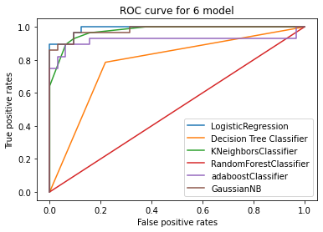

LG AUC score 0.9888392857142857

DTC AUC SCORE 0.7834821428571428

KNN auc score 0.9754464285714286

Random forest classifier 0.984375

Adaboost classifier 0.9185267857142858

Gaussian NB 0.9810267857142858

**Conclusion;**

The hightest aacuracy score is achieved by Logistic Regression.

Also we know that,higher the AUC score,better the

model is working **..**

LOGISTIC REGRESSION with accuracy of

91% & AUC score of 98% is best among all model.

So we save it as the best model

**import** **joblib**

joblib.dump(lg,'heartdisease.pkl')